VIETNAM NATIONAL UNIVERSITY OF HOCHIMINH CITY

THE INTERNATIONAL UNIVERSITY

SCHOOL OF COMPUTER SCIENCE AND ENGINEERING



**PROJECT REPORT**

**Internship IU**

By

Tran Hai Nam

Advisers:

Dr. Huynh Kha Tu

A thesis submitted to the School of Computer Science and Engineering

in partial fulfillment of the requirements for the degree of   
Bachelor of Information Technology/Computer Science/Computer Engineering

Ho Chi Minh City, Vietnam  
Year 2023

**Web app**

**Internship IU**

APPROVED BY: ________________________________ ,   
Tran Hai Nam – ITITIU19161

________________________________

THESIS COMMITTEE   
(Whichever applies)

# TABLE OF CONTENTS

TABLE OF CONTENTS 3

TABLE OF FIGURES 4

CHAPTER 1 5

INTRODUCTION 5

1.1. Introduction 5

1.2. Arms projects 5

CHAPTER 2 5

PLAN OF PROJECT 5

2.1. Student requires 5

2.2. Teacher requires 7

2.3. Admin 7

2.4. Design System: 7

2.4.1. Use case diagram: 7

2.5. Main Workflow 9

CHAPTER 3 10

GOAL ATTAINMENT 10

3.1. Current work. 10

3.1.1. Students 10

3.1.2. Teacher 15

3.1.3. Admin 18

3.2. Compare with the initial requirements. 19

3.2.1. Teacher 19

3.2.2. Student 20

3.2.3. Admin 20

CHAPTER 4 20

FUTURE WORK 20

4.1. Compete Project 20

4.2. Some add function 20

# TABLE OF FIGURES

Figure 1: Example for jobs list 6

Figure 2: use case diagram 8

Figure 3: Workflow 9

Figure 4: login page 10

Figure 5: User information page 11

Figure 6: Home page of students 11

Figure 7: Modal of job view 12

Figure 8: Jobs page 12

Figure 9: company page 13

Figure 10: Apply form. 13

Figure 11: Display jobs applied page. 14

Figure 12: Register job form 14

Figure 13: Register instructor form 15

Figure 14: Report page 15

Figure 15: Home page of Teacher 16

Figure 16: View Student 16

Figure 17: Announcement form 16

Figure 18: Grading form 17

Figure 19: Grade view page 17

Figure 20: Report page 18

Figure 21: Manager User 18

Figure 22: Manager companies 19

Figure 23: Manager Jobs 19

# 

# CHAPTER 1

# INTRODUCTION

## Introduction

Project Internship IU was started because it recognized the needs and difficulties of the students in applying for the internship. The main difficulties revolve around the lack of clarity in understanding the internship sequence, especially in finding internship companies. The teacher guides and evaluates the practice content.

## Arms projects

The main goal of the project is to use technologies to create a web app that can support and make it easier for students to find a credit-up company to practice and track the process. own practice. Teachers are also more proactive in supporting students during the internship and quickly making a report for the school fee about the student's internship process.

# CHAPTER 2

# PLAN OF PROJECT

An internship project is a project to support the internship process in school. The project will have two main objects, which are the Teacher and the Student. So that is why the project will be built with two interfaces for 2 objects. Extra object is admin how manage website.

## Student requires

User Authentication: Create a Login page. The student accesses the web use their student account and web app will redirect to student page.

Jobs list: The website should have a list of internships available for students (This will show in center home page), which should include the job title, company name, job description, location, and application deadline.

Figure : Example for jobs list

Figure 1 is an example of UI to display jobs for student’s website will have.

Company profiles: The website should allow companies to create a profile, which should include information about the company, its mission, vision, and values, and a list of current jobs they hire.

Communication tools: The website should have a built-in communication system that allows students and companies to communicate with each other regarding the application process. The students can also communicate with their teacher and instructor on this website.

Writing Curriculum Vitae (CV): The website supports creating CV forms for students to fill out and save in the system. Students also upload their personal CV on page CV.

Application process: The website should allow students to apply for internships by submitting their CVs and cover letters. The application should also include a form that captures the student's personal details such as name, email address, phone number, and educational background.

Notifications: The website can send notifications to students when a new internship is posted that matches their preferences and notify companies when a student applies for one of their internships. The website also sends notifications to teachers when students change their status of having received or completed an internship.

Chat: The website provides a chat method for students to communicate with their teacher and instructor.

Dashboard: The website should provide a dashboard for students and teachers to keep track of student’s applications and the status of their applications.

Report from: The website provides a list or form of internship report for students. Students can submit their report on this web app.

## Teacher requires

User authentication: The teachers will use accounts which are provided by the school to login to this web app.

Manger Student: The website supports Teachers to see all the students they manage. Teachers can visit the student page to view their CVs and make suggestions for students' CVs.

Dashboard: The website should provide a dashboard for students and teachers to keep track of student’s applications and the status of their applications.

Grading: During the time before the internship period ends, the website will send a notice to students for students to submit internship reports and teachers based on that to give student grades. Websites have a page for Teacher view again and edit after that they can export it to submit for school.

Notifications: The website will send notifications to Teacher when the students apply a job or register their instructor.

Chat: The website will provide a chat box for teachers to communicate with students.

Report form: website also provides list of report form for teachers make report.

## Admin

Admin panel: The website should have an admin panel that allows administrators to manage the internship listings, company profiles, and user accounts.

## Design System:

### Use case diagram:

Based on some requirements and analysis of the website. The Internship IU web app will have 2 main actors are students, teachers and extra actor is admin.

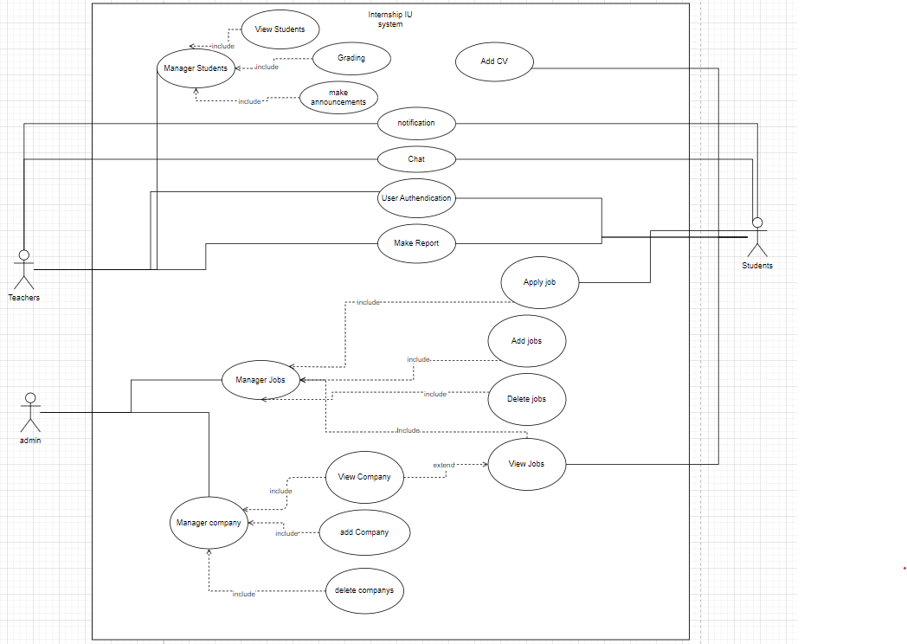

Figure : use case diagram

The website will have list of functions:

* Manager Students: This is function of Teacher. Manager Students will include:
  + View Students: web display list student
  + Grading: Show form to grading for student
  + Make announcements: form to send announcements for students (it also sends announcements via email)
* Add CV: Make upload file for students to submit their CV.
* Chat: a chat box for students and teacher can communicate.
* User Authentication: Use account provided by school to access.
* Make Report: provide list of templates for students and teacher.
* Manager jobs:
  + Apply job: form apply job and sent mail to recruiter of company.
  + View job: display list card job for student.
  + Add job: add new job follow form to add database.
  + Delete job: remove job out of database.
* Manager company:
  + View Company: a page displays company information.
  + Add company: add company to database.
  + Delete company: remove company out of database.

## Main Workflow

In this website have 2 users are teacher and students.

Students workflow :

The main purpose of students will be to use the website to search for intern jobs that the school has selected and introduced on the web. Before applying for a job, students must submit a CV. When students apply for a job, they will send their CV and cover letter by email and have it signed by the school. The process of applying for internship jobs will take place according to the company's process. When the job application is successful, students will go to the website to register according to the sample forms. The registration information will be sent to the teacher for confirmation. After being confirmed by the teacher, the internship will take place according to the company's side. When the internship is nearing its end, the school will automatically send a notification to the students to switch to report writing status. Students will send a report to the teacher and finish the internship.

Teacher workflow:

The teacher's main job is to manage students and grade students' internships. Teachers will check students by way and each student's page to see the student's Cv test information, Confirm the student's work when the student has applied for the job. Get Graded Student Report. After the grading is completed, the teacher will write a final report for the school to end the student's internship.

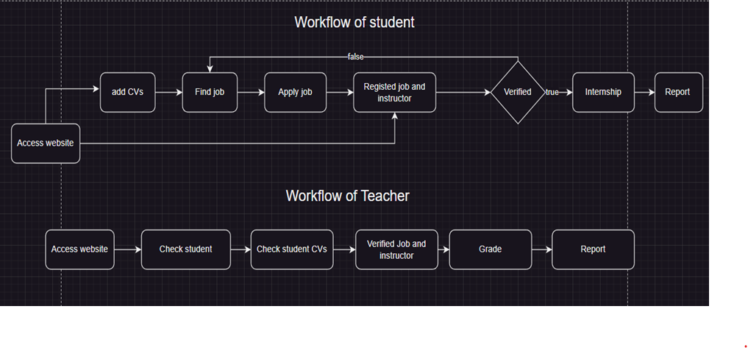

Figure : Workflow

# CHAPTER 3

# GOAL ATTAINMENT



## Current work.

A page on users is the authentication page here is a page for students or Teachers will use their account provided by the school to access Internship IU.

Figure : login page

### Students

This information of student page will display all critical information about students and show the processed internship of students.

The student's internship process will have 5 statuses: application, job registration, internship, thesis writing, final grading and the end of the internship. The application status is the initial state, only when the student registers the job information as well as the instructor information for the teacher, it will switch to the second state. After being confirmed by the teacher, it will switch to internship status. the fourth state of writing the report will automatically change when the date the school requires the report, and go to the last state when the student submits the report.

Figure : User information page

Next is the home page of the student role. On this page display list of jobs for students applying. Jobs will display base on Students area of expertise.

Figure : Home page of students

This modal display details of jobs for students can read and apply for jobs. Modal job will display name, company name, requirement, description, …

Figure : Modal of job view

When user click title of job in modal job it will redirect to company page.

Figure : Jobs page

The website also has a company page for students to view more information about that company and understand what company they apply to.

Figure : company page

The application form page will display job and student information will send to the recruiter by mail.

Figure : Apply form.

The jobs applied for will display on the applied page. On this page, students can register their job if they can find a job outside or student receive a job from the Company they apply.

Figure : Display jobs applied page.

Figure : Register job form

Figure : Register instructor form

After finishing the internship, they can find a report form on this website and submit it through the Internship IU website.

Figure : Report page

### Teacher

Teachers will see a list of students and their managers. On this page, Teach can quickly observe the process of student support immediately.

Figure : Home page of Teacher

When clicking on the student card. The web will redirect to the student page to view detail. On this student page, the teacher can grade and make an announcement if students have problems with their CVs or report.

Figure : View Student

Announcement form:

Figure : Announcement form

Grade form

Figure : Grading form

This grade page will display a list of students with their grades, easy for the teacher to observe and modify if the Teacher has a problem. It also can export for teacher can make a report for school later.

Figure : Grade view page

Teachers can find some report forms on this page and submit them to the school by mail.

Figure : Report page

### Admin

The admin page will give the admin all the rights to view and modify information for users such as accounts, roles, companies, and even jobs.

Admin will manage 3 main objectives on website are User, Company, and Jobs. Admin's main activity is to add jobs and companies.

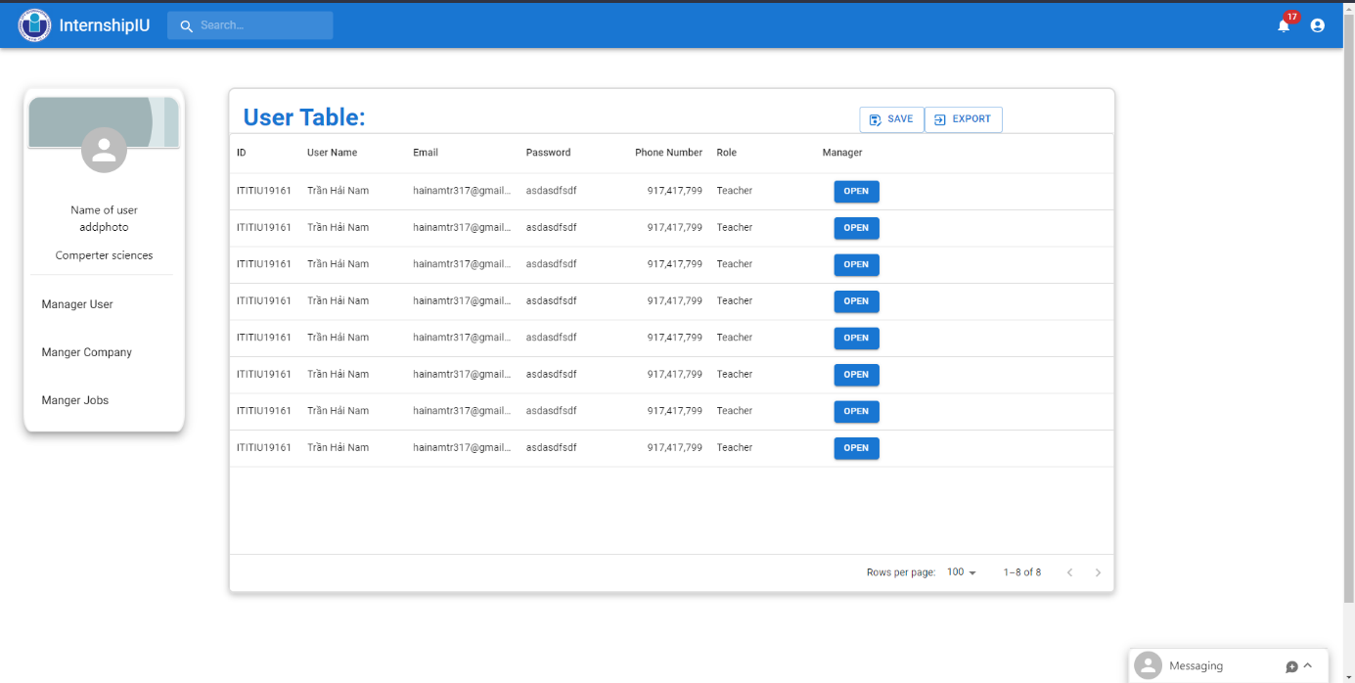

Figure : Manager User

Figure : Manager companies

Figure : Manager Jobs

## Compare with the initial requirements.

Overall, it can be said that the UI design for two main users, teachers, and students, can be said to be completed.

The biggest change is to systematize the main website users instead of having the role of an instructor so that students can communicate via the web. But it will be more convenient to exchange students and instructors using external chat applications, which is both more convenient and ensures confidentiality for the instructor's company.

Compared with the original requirements, there is a relative change.

### Teacher

About the role design for teachers, it can be said that it is completely compared to the requirements set out in terms of student management, grading, making announcements as well as assisting in submitting reports.

### Student

On the part of students, the demand has also been completed compared to the requirements for the functions of sending CVs, finding jobs, communicating with teachers, receiving internship information, as well as making reports.

There is a slight change in job applications that students have additional forms to assist in applying for cases where the student has already found a job outside. At the same time, the application process has also been revised to make it more reasonable that the application will be submitted via mail. After students receive an interview response email and receive a job, they can also use that word to apply for jobs as well as mentors for the teacher.

Complete the student internship registration process.

### Admin

The UI has met the requirements for the Admin object again. Admin has full authority in managing user information, company information, and jobs.

# CHAPTER 4

# FUTURE WORK



## Compete Project

Add a backend to complete existing functionality as well as push to a common database.

Optimize UI to make it more convenient for users to use the website. Edit the registration forms according to the school's registration forms.

Compete chat function can use api from third application to support communication some third party application like Facebook, Zalo,...

## Some add function

* For Admin, add the function of creating notifications to be able to create total notifications for students.
* For Student and Teacher about report page will make a button to sent report thought mail.
* Add Filter searching for student easy find job.
* Make a button to upload grades on the Grade page of the teacher. When the teacher clicks it buttons it will send the grade following the ID of students to the database of school to upload the grade in Edusoft

My source code

https://github.com/hainamtr317/InternshipIU.git